HR Questions

1. Why you want to leave your current job.

Link : <https://www.youtube.com/watch?v=sB2xKJ25E2Y>

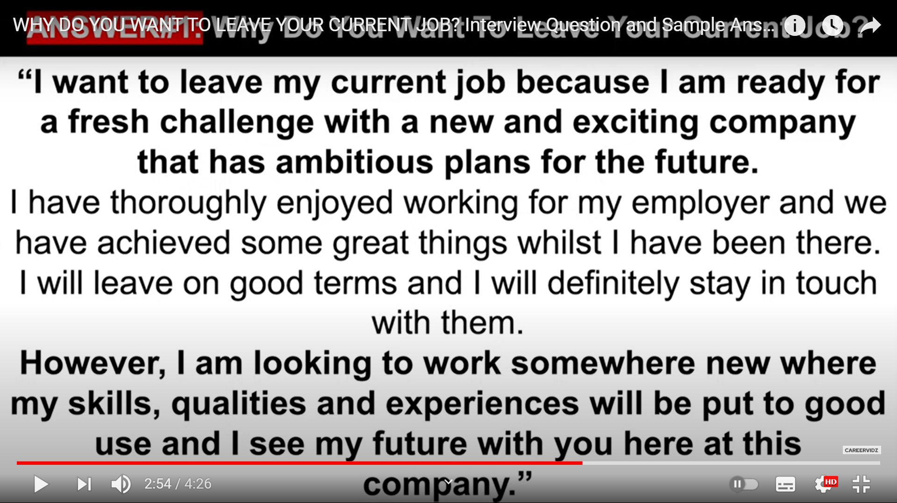

To gain new experiences.

1. Top 25 questions

<https://www.youtube.com/watch?v=KCm6JVtoRdo>

1. Hha

S : Situation

T : Task Performed

A: Action

R : Result

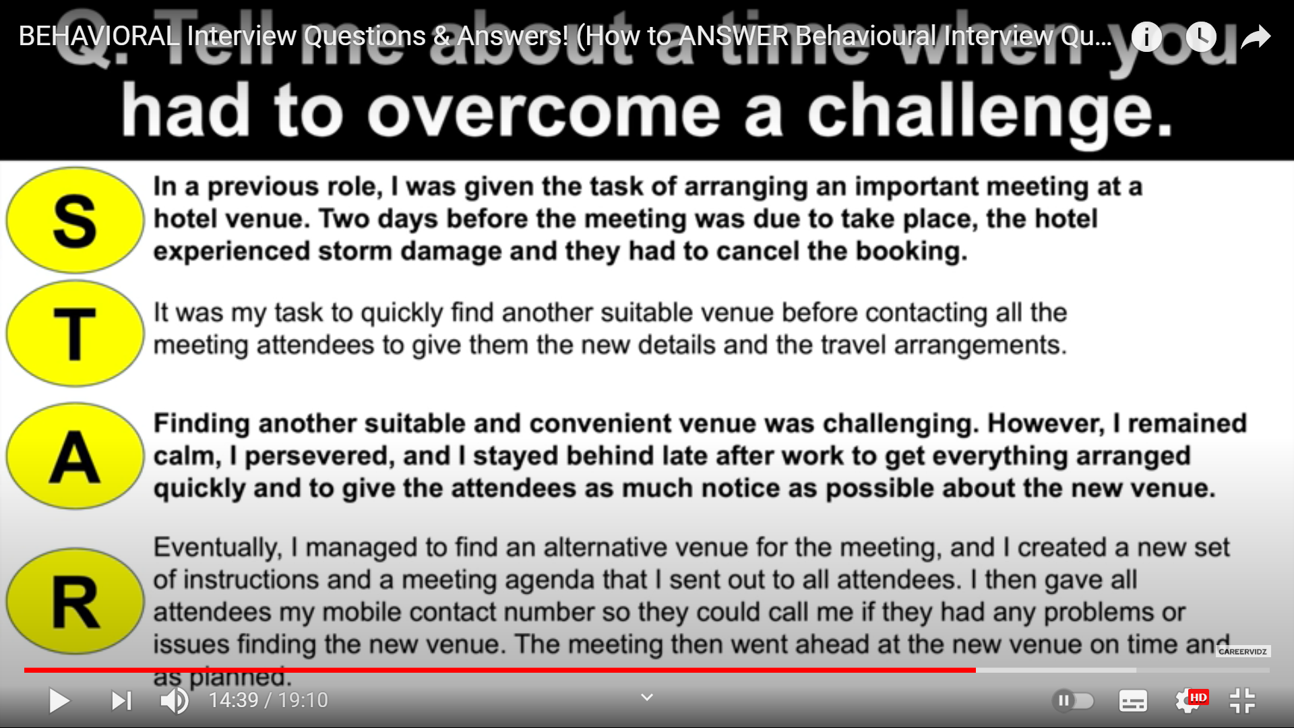

1. List of questions

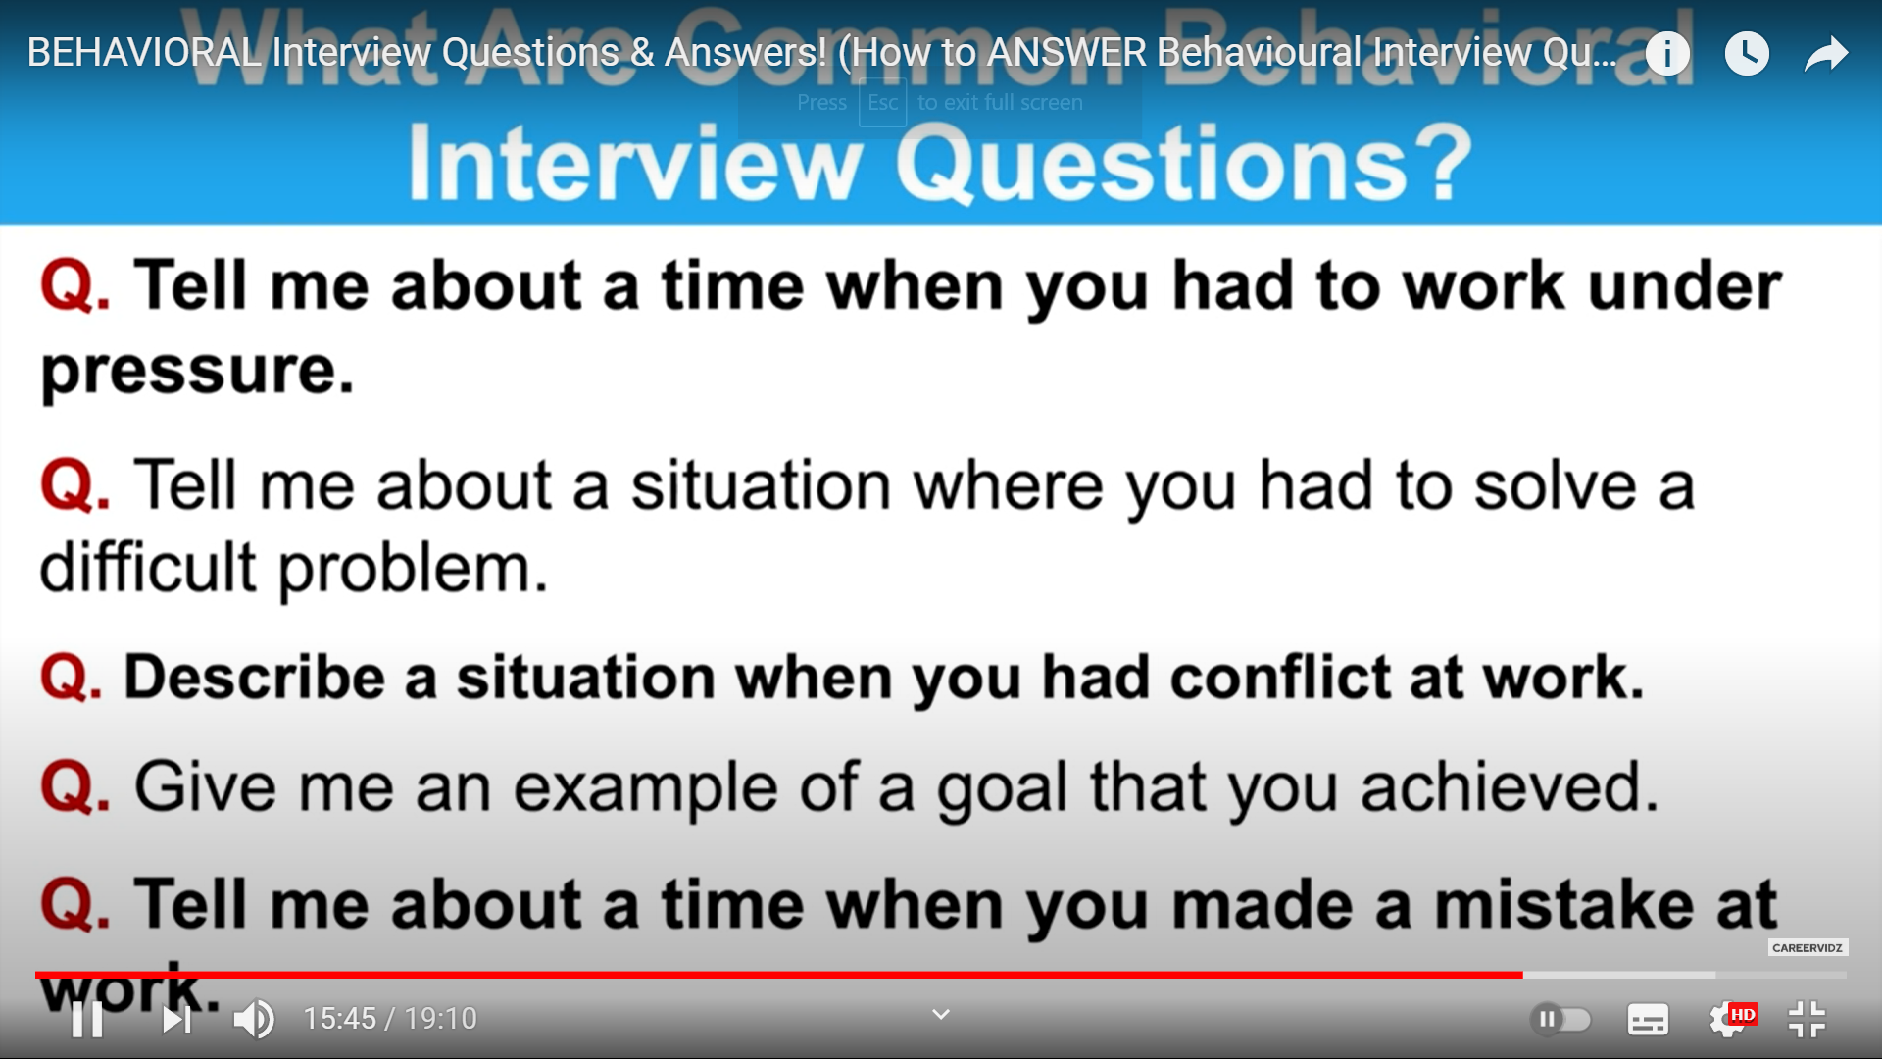

5.

